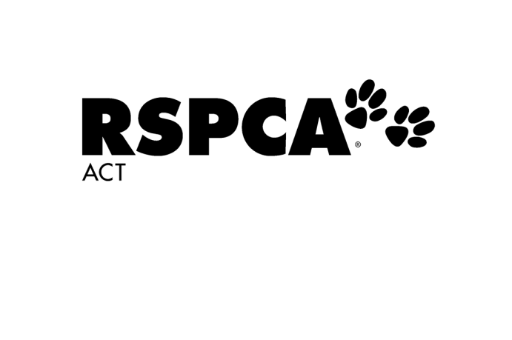

**Office Use Only**

Booking ID: _____________________

Deposit Paid: $__________________

Amount Owing: $________________

Suite Number: __________________

Documents Uploaded:

**Tango’s Cat Boarding – Booking Form – New Guest/s**

Boarding from: (select date) Boarding to: (select date)



Number of nights: Number of cats boarding:

Would you like your cats to share suites?  Yes  No  N/A

**Type of Suite**

Weekender  Standard Suite  Executive Suite

**Your Details**



Full Name:



Address:



Email Address:



Mobile Number:



Emergency Contact Name:



Emergency Contact Number:



Nominated Veterinary Clinic:



Vet Clinic Phone Number: (if not RSPCA)

I have attached a copy of my treatment agreement with the above vet (as per [terms and conditions](http://www.rspca-act.org.au/sites/default/files/Tangos%20Cat%20Boarding%20-%20Terms%20and%20Conditions.docx))

I would like to receive Select SMS photos of my cat(s) to the above mobile number

I give permission for my cat/cats image to be used in RSPCA ACT publications and website

I would like to be added to the RSPCA ACT mailing list and go into a quarterly draw to win one of two RSPCA ACT gift vouchers valued at $75

I confirm that all information above is correct and understand the [terms and conditions](http://www.rspca-act.org.au/sites/default/files/Tangos%20Cat%20Boarding%20-%20Terms%20and%20Conditions.docx)



* I found out about Tango’s Cat Boarding: (please select one)

At time of Adoption  Internet Search  Facebook  Instagram

Recommendation  RSPCA Newsletter  Other:

Payment

I would like to pay by:  Over the phone  Mastercard  VISA



Name on Card:



Card Number:



Expiry Date: CCV Number:

**Guest Details** – Cat 1



Name: Age/DOB: Gender: Select



Breed: Colour:



Microchip Number: Vaccination Certificate Attached? Select



Do they have any unique behaviour?



What is their favourite toy?



Do they enjoy being groomed?



What makes them happy?



What makes them unhappy?

If they are feeling a bit stressed, is it normal for them to: (tick all that apply)

Not eat or toilet  Sneeze  Have a weepy eye(s)  Toilet inappropriately

Vomit  Diarrhoea  Growl/Strike or Bite  Hide

Special Instructions:



**Guest Details** – Cat 2



Name: Age/DOB: Gender: Select



Breed: Colour:



Microchip Number: Vaccination Certificate Attached? Select



Do they have any unique behaviour?



What is their favourite toy?



Do they enjoy being groomed?



What makes them happy?



What makes them unhappy?

If they are feeling a bit stressed, is it normal for them to: (tick all that apply)

Not eat or toilet  Sneeze  Have a weepy eye(s)  Toilet inappropriately

Vomit  Diarrhoea  Growl/Strike or Bite  Hide

Special Instructions:



**Continue to page 3 if booking in a third cat**

Please email completed form, along with vaccination certificate/s and veterinary treatment agreement (if not utilising RSPCA veterinary services) to:

[pac@rspca-act.org.au](mailto:pac@rspca-act.org.au)

**Guest Details -** Cat 3



Name: Age/DOB: Gender: Select



Breed: Colour:



Microchip Number: Vaccination Certificate Attached? Select



Do they have any unique behaviour?



What is their favourite toy?



Do they enjoy being groomed?



What makes them happy?



What makes them unhappy?

If they are feeling a bit stressed, is it normal for them to: (tick all that apply)

Not eat or toilet  Sneeze  Have a weepy eye(s)  Toilet inappropriately

Vomit  Diarrhoea  Growl/Strike or Bite  Hide

Special Instructions:



Please email completed form, along with vaccination certificate/s and veterinary treatment agreement (if not utilising RSPCA veterinary services) to:

[pac@rspca-act.org.au](mailto:pac@rspca-act.org.au)