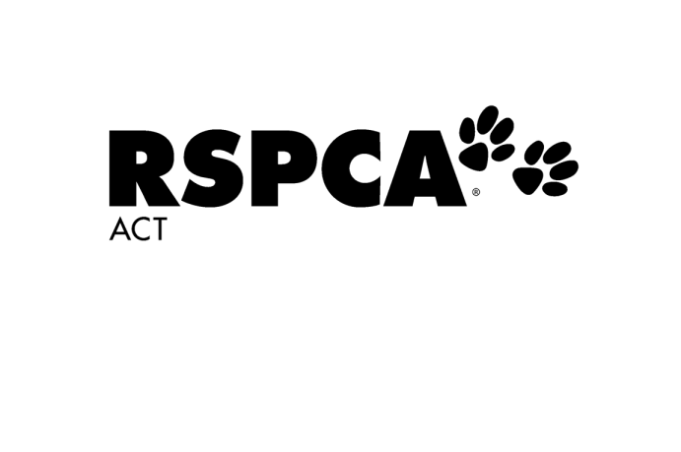**Dog Training School – Register Interest**

In which class would you like to register interest? Select a Class

If you are unsure, please advise your dog’s DOB and we will book appropriately

**Your Details**



Full Name:



Email Address:



**Mobile Number:**

I found out about RSPCA ACT’s Dog Training School: (please select one)

At time of Adoption  Internet Search  Facebook  Instagram

Recommendation  RSPCA Newsletter  Other:

**Dog’s Details**



Name: Age/DOB: Gender: Select



Breed: Colour:

Please email completed form to [pac@rspca-act.org.au](mailto:pac@rspca-act.org.au) and you will be added to our priority waiting list and contacted as soon as a class is released.