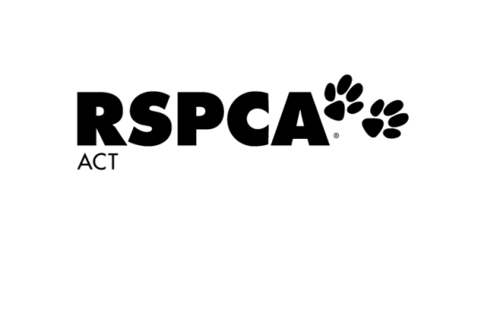

**Tango’s Cat Boarding – Enquiry only**



Boarding from: (select date) Boarding to: (select date) Number of nights:



Number of cats boarding: Would you like your cats to share suites?  Yes  No  N/A

**Type of Suite**

Weekender  Standard Suite  Executive Suite

**Your Details**



Full Name: Phone Number:



Email Address:

I found out about Tango’s Cat Boarding: (please select one)

At time of Adoption  Internet Search  Facebook  Instagram

Recommendation  RSPCA Newsletter  Other:

*Please note that this booking enquiry does not secure a suite should you wish to proceed with booking.*



Email completed form to: [pac@rspca-act.org.au](mailto:pac@rspca-act.org.au)